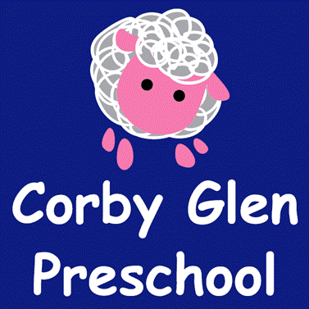
Healthy Eating Policy

Corby Glen Preschool is committed to meeting the EYFS Welfare Requirements and the individual needs of children attending.

We aim to do this by:
- Discussing with parents on their child’s entry to the setting their individual dietary needs, any allergies and any religious requirements.
- Recording information about individual children and ensuring that all staff are aware of those needs.
- Providing nutritious food using fresh produce.
- Ensuring that where children bring packed lunches parents are aware of the need to provide healthy foods.
- Discussions with parents regarding their children’s’ needs on a regular basis and updating records accordingly.
- Ensuring that snack times are varied, that children and parents are consulted and can ask for information regarding their child’s choice of snack.
- Ensuring that children are offered food and snacks according to parents’ wishes, cultural and medical requirements and individual needs.
- Informing parents of the storage facilities for food and drinks.
- Ensuring that children are offered age appropriate utensils.
- Providing meal times that are social times where children feel comfortable, staff participate, and independence is encouraged.
- Working with required agencies to ensure all requirements are met with regard to the handling and preparation of food.
- We will make every effort to help educate the children and parents about the importance of a healthy balanced diet, and the importance of a healthy lifestyle.

We will take into consideration cultural, religious and other dietary requirements when planning our menus, and by working in close partnership with parent/carers will ensure that we meet their child’s particular needs. This will also provide us with a valuable opportunity to introduce all of the children that attend our setting to different cultural food types.

Food and Drink Preparation

All Staff at Corby Glen Preschool have a duty and responsibility for the correct maintenance of food and drink preparation areas.
- Staff will undertake appropriate food hygiene training both external and internal.
- Surfaces will be cleaned before and after any food/drink preparation.
- Food and drink preparation areas will be used solely for that purpose.
- Faults and breakages will be reported to the manager.
- Equipment will be checked regularly as per regulatory requirements.
- The premises will hold the required environmental health certificate.

All staff will endeavour to undertake Food Hygiene training.

Oral Hygiene
Corby Glen Preschool will have an awareness of child oral hygiene and support the children within the setting by promoting this. The children’s records will shoe if they are registered with a dentist. Senior staff will discuss oral hygiene with parents and support and encourage them to register their child with an NHS dentist and suggest regular appointments are made.

04.6 Oral health
The setting provides care for children and promotes health through promoting oral health and hygiene, encouraging healthy eating, healthy snacks and tooth brushing.
- Fresh drinking water is available at all times and easily accessible.
- Sugary drinks are not served.
- In partnership with parents, babies are introduced to an open free-flowing cup at 6 months and from 12 months are discouraged from using a bottle.
- Only water and milk are served with morning and afternoon snacks.
- Children are offered healthy nutritious snacks with no added sugar.
- Parents are discouraged from sending in confectionary as a snack or treat.
- Staff follow the Infant & Toddler Forum’s Ten Steps for Healthy Toddlers.
- Parents are encouraged to change toothbrushes every 3 months.
- Oral hygiene activities are included in planning.
Pacifiers/dummies
- Parents are advised to stop using dummies/pacifiers once their child is 12 months old.
- Dummies that are damaged are disposed of and parents are told that this has happened
Further guidance
Infant & Toddler Forum: Ten Steps for Healthy Toddlers www.infantandtoddlerforum.org/toddlers-to-preschool/healthy-eating/ten-steps-for-healthy-toddlers/

This policy has been adopted by Corby Glen Preschool.

Signed on behalf of the setting by:

………………………………………………………….. Chairperson

………………………………………………………..Manager

Date:

Review Date:

